**MODEL SUMMARY – ENHANCED SHIELDING**

**Model Equations**

$$\frac{dS_{v}}{dt}=-β_{1}I_{v}S_{v}-β_{1}I_{h}S_{v}-β_{1}I_{n}{c_{b}S}_{v}-β_{1}{b_{v}{0.5(1-c}_{b})I}_{v}S_{v}-β_{1}{b_{v}{0.5(1-c}_{b})I}_{h}S_{v}+ζR_{v}$$

$$\frac{dS_{h}}{dt}=-β_{2}I_{h}S_{h}-β_{2}I_{n}S_{h}-β_{1}I_{v}S_{h}+ζR_{h}$$

$$\frac{dS_{n}}{dt} =-β_{3}I_{n}S_{n}-β_{2}I_{h}S_{n}-β_{1}I_{v}{c_{b}S}_{n}-β_{3}{b_{n}{(1-c}_{b})I}_{n}S_{n}+ζR_{n}$$

$$\frac{dI_{v}}{dt}=β_{1}I_{v}S_{v}+β_{1}I_{h}S_{v}+β_{1}I_{n}{c_{b}S}_{v}+β_{1}{b_{v}{0.5(1-c}_{b})I}_{v}S_{v}+β_{1}{b_{v}{0.5(1-c}_{b})I}_{h}S_{v}-γI_{v}$$

$$\frac{dI_{h}}{dt}=β_{2}I_{h}S_{h}+β_{1}I_{v}S_{h}+β_{2}I_{n}S_{h}-γI_{h}$$

$$\frac{dI_{n}}{dt}=β_{3}I_{n}S_{n}+β_{2}I_{h}S_{n}+β_{1}I_{v}{c_{b}S}_{n}+β_{3}{b_{n}{(1-c}_{b})I}_{n}S_{n}-γI_{n}$$

$$\frac{dR_{v}}{dt}=γI_{v}-ζR_{v}$$

$$\frac{dR_{h}}{dt}=γI_{h} -ζR_{h}$$

$$\frac{dR_{n}}{dt}=γI_{n} -ζR_{n}$$

|  |  |  |
| --- | --- | --- |
| Compartment | Description | Initial Conditions |
| Sv | Susceptible fraction of the population who are vulnerable | 0.2 – 0.00002 |
| Sh | Susceptible fraction of the population who are shielders | 0.2 – 0.00002 |
| Sn | Susceptible fraction of the population who are non-vulnerable | 0.6 – 0.00006 |
| Iv | Infectious fraction of the population who are vulnerable | 0.0001/ 0.2 |
| Ih | Infectious fraction of the population who are shielders | 0.0001/ 0.2 |
| In | Infectious fraction of the population who are non-vulnerable | 0.0001/ 0.6 |
| Rv | Removed fraction of the population who are vulnerable | 0 |
| Rh | Removed fraction of the population who are shielders | 0 |
| Rn | Removed fraction of the population who are non-vulnerable | 0 |

|  |  |  |
| --- | --- | --- |
| Parameter | Description | Value |
| R0 | Baseline basic reproduction number | 2.8 |
| T2 | Doubling time | 3.3 days |
| β | Per capita rate of infectious transmission (R0 = 1.7) | 0.198 day-1 |
| γ | Per capita rate of recovery | 0.1167 day-1 |
| ζ | Per capita rate of immunity loss | 0.0027 day-1 |
| Cb | Relative level of contact between the vulnerable and non-vulnerable groups at baseline | 0 – 1 |
| Ci | Relative level of contact between the vulnerable and non-vulnerable groups during the intervention | 0 |
| bv |  |  |
| bn |  |  |

**Modelling Contact Structure and Beta Inflation**

**Before the Intervention**

Using an SIRS-type model structure and assuming density-dependent contact, the fraction of new infecteds at each timestep is a function of the per-capita rate of infectious contact (β), the fraction of infected individuals (I) and the fraction of susceptible individuals (S). This functions under the assumption of a homogenously mixed population, with susceptible individuals being equally exposed to the entire infected fraction.

Using the vulnerable, shielded and non-vulnerable population structure in this model, under a homogenously mixed population the vulnerable susceptible fraction (Sv), would have equal exposure to the fraction of infecteds from the vulnerable, shielders and non-vulnerable populations (Iv + Ih + In). This is what was assumed in the previous model structure (14/04/20).

$$\frac{{dS}_{v}}{dt}=-β_{1}I_{v}S_{v}-β_{1}I_{h}S_{v}-β_{1}I_{n}S_{v}$$

|  |  |  |  |
| --- | --- | --- | --- |
|  | Vulnerable | Shielders | Non-Vulnerable |
| Vulnerable | β1 | β1 | β1 |
| Shielders | β1 | β2 | β2 |
| Non-Vulnerable | β1 | β2 | β3 |

However, we assume that there is contact structure in the underlying population, with the vulnerable and non-vulnerable fraction having limited/reduced contact. A fully structured population with 0 contact between these two populations will result in the vulnerable population only being in contact with the vulnerable and shielder infected fraction (Iv + Ih).

|  |  |  |  |
| --- | --- | --- | --- |
|  | Vulnerable | Shielders | Non-Vulnerable |
| Vulnerable | β1 | β1 | 0 |
| Shielders | β1 | β2 | β2 |
| Non-Vulnerable | 0 | β2 | β3 |

However, a more realistic contact structure would involve an intermediate level between a fully structured population and a 100% homogenously mixing population. Let us introduce the parameter, cb, which models the relative level of contact between the vulnerable and non-vulnerable population. This relative scaling parameter modifies the extent of transmission between these two groups.

$$\frac{{dS}_{v}}{dt}=-β_{1}I_{v}S_{v}-β_{1}I_{h}S_{v}$$

|  |  |  |  |
| --- | --- | --- | --- |
|  | Vulnerable | Shielders | Non-Vulnerable |
| Vulnerable | β1 | β1 | cb*β1 |
| Shielders | β1 | β2 | β2 |
| Non-Vulnerable | cb*β1 | β2 | β3 |

However, through introducing a reduced level of contact/exposure between the vulnerable and the non-vulnerable population, the relative fraction of new infections across the three compartments is now unequal and the effective R0 is reduced. Conceptually, this is because the shielders are equally exposed to infection from 100% of the infected population, while the vulnerables and non-vulnerables are exposed to fractions of these, Iv+Ih and Ih+In respectively.

This presents an issue, as we would want all populations to have the same baseline R0 before interventions are introduced into the model. This is not the case when this population structure is introduced. To retain identical R0 across populations, existing beta values need to be inflated in the vulnerable and non-vulnerable populations, to account for this loss in contact/exposure. This β inflation occurs to the shielders-to-vulnerable (βvh) and vulnerable-to-vulnerable (βvv), and the non-vulnerable-to-non-vulnerable (βnn) transmission routes for the vulnerable and non-vulnerable population respectively.

The inflation is explicitly modelled as additional inflated transmission occurring in their respective compartments (in addition to the non-inflated transmission). 1-cb is used to “fill in” the lost exposure between the vulnerable and non-vulnerable groups according to the relative level of infectious contact between the groups, cb. We also introduce a bv and bn parameter to rescale this inflation to the relative population size of the vulnerable to the non-vulnerable groups and vice versa. The inflation is split between the two transmission routes (by 0.5) for the vulnerable population due to two transmission routes being inflated, βvv and βvh. After this inflation, all modelled population groups will have identical R0 values at baseline, despite the unequal contact structure.

$$\frac{{dS}_{v}}{dt}…-β_{1}{b_{v}{0.5(1-c}_{b})I}_{v}S_{v}-β_{1}{b_{v}{0.5(1-c}_{b})I}_{h}S_{v}-…$$

Inflated β are denoted in bold:

|  |  |  |  |
| --- | --- | --- | --- |
|  | Vulnerable | Shielders | Non-Vulnerable |
| Vulnerable | **β1** | **β1** | cb*β1 |
| Shielders | β1 | β2 | β2 |
| Non-Vulnerable | cb*β1 | β2 | **β3** |

**After the Intervention**

As the lockdown intervention triggers, the entire population completely trifurcates with strict population structure being applied. The inflated betas still apply, but all infectious contact between the vulnerable and non-vulnerable population is removed (cb -> 0 or ci).

**Modelling Enhanced Shielding and Beta Alteration**

|  |  |  |  |  |  |
| --- | --- | --- | --- | --- | --- |
| Phase | | Timing | Beta1 | Beta2 | Beta3 |
| 0 | | Until Trigger Day (Currently Day 71) | 0.198 | 0.198 | 0.198 |
| 1 | | 6 Weeks | 0.070 | 0.070 | 0.070 |
| 2 | a | 12 Weeks  (Linear change from  0.070) | 0.070, 0.056, 0.042, 0.028, 0.014, 0 | 0.070, 0.096, 0.121, 0.147, 0.173, 0.198 | 0.198, 0.224,  0.249, 0.275,  0.301, 0.326 |
| b | 12 Weeks Onwards | 0.070, 0.056, 0.042, 0.028, 0.014, 0 | 0.070, 0.096, 0.121, 0.147, 0.173, 0.198 | 0.198, 0.224, 0.249, 0.275, 0.301, 0.326 |

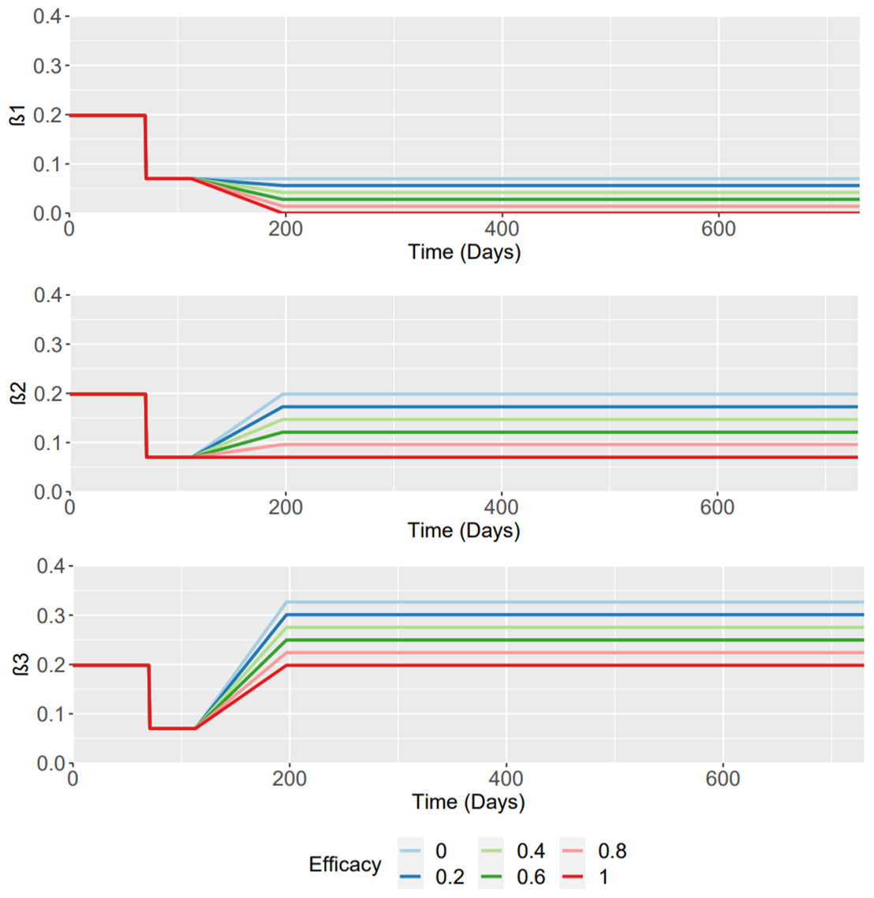

**Figure 1 - Interventions to the Beta Parameters**